Concept of class in python

class Cat:

def __init__(self,color,legs):

self.color=color

self.legs=legs

def __str__(self):

return self.color +','+str(self.legs)

if __name__=="__main__":

pet1=Cat("ginger",4)

print(pet1.legs)

print(pet1.color)

print(pet1)

pet2=Cat("brown",3)

print(pet2.color)

print(pet2.legs)

print(pet2)

**OUTPUT**

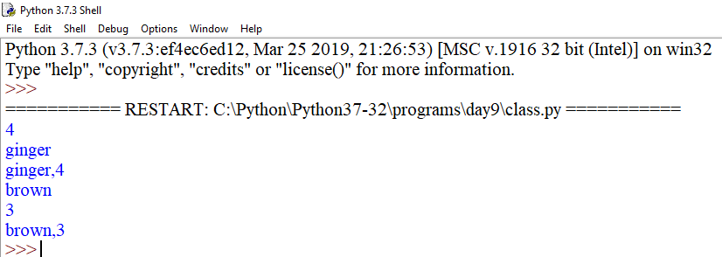

class Dog:

price=400

def __init__(self,name,color):

self.color=color

self.name=name

def bark(self):

print("Woof")

print(self.name, "has",self.price,"price and its color is",self.color)

if __name__=='__main__':

pet1=Dog("Tommy","brown")

pet2=Dog("Shern","white")

pet1.bark()

pet2.bark()

print(pet1.price)

print(pet2.price)

print(Dog.price)

Dog('abc','blue').bark()

**OUTPUT**

